HOSPITAL INFORMATION SYSTEMS

Subsystems:

* Registration System
* Patient Management
* Employee Management
* Diagnostic center Management
* Billing System
* Scheduling System

Actors:

* Receptionist
* Doctor
* Patient
* Diagnostic Center Assistant
* Clerk
* Employee
* Data Entry Manager
* Diagnostic Center Manager
* Human Resources Officer

Actors Glossary

|  |  |  |
| --- | --- | --- |
| Patient | PT | Registers in the system, makes appointment , receives treatment, requests for medical test, pays bill |
| Human Resource officers | HRO | Receives duty schedule and distributes them to employees |
| Administrator | AD | Maintains the system , has access to every part of the system and some jobs are done only by him |
| Data Entry Manager | DEM | Enters and updates database |
| Clerk | CLK | Collects bill |
| Diagnostic Center  Manager | DCM | Maintains liaison between patient and diagnostic center  cabin, receive requests for tests |
| Diagnostic Center Assistant | DCA | Collects sample and prepare report |
| Doctor | DOC | Treats the patient, refer medical test , discharge a patient |
| Employee | EMP | Hospital employees |

1. Registration System

Use-Case Glossary:

|  |  |  |
| --- | --- | --- |
| Use-case ID>Name | Description | Participant Actors and roles |
| 1.1>Register Patient | PT completes the registration process by giving necessary information to RCP | PT,RCP |
| 1.2>Prepare Current Patient List | AD will prepare the current patient list | AD |
| 1.3>View Current Patient List | RCP,AD can see the current patient list | RCP,AD |

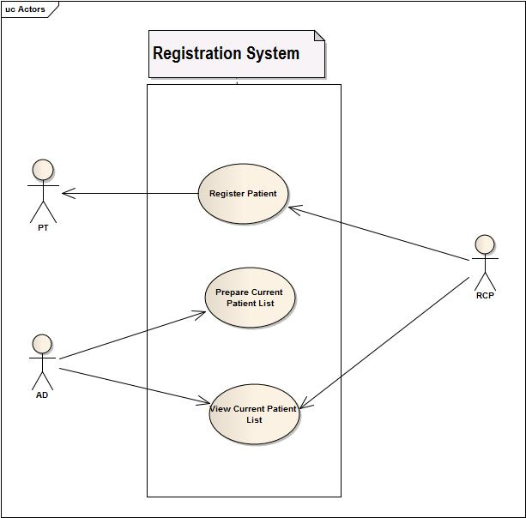

Fig: use-case diagram of registration system

1.1Resgister Patient

|  |  |
| --- | --- |
| USE CASE NAME | DEFINE ROUTE AND PRICE |
| USE CASE ID | 1.1 |
| Priority | High |
| Primary Business Actor | Patient (PT) |
| External Receiver Actor | Receptionist (RCP) |
| Description | Receptionist takes the information of the patient and registers him in the system |
| Trigger | By Patient |

**Table:** *Use-Case Narrative:* Register Patient

Typical Course of Events:

|  |  |
| --- | --- |
| Actor Action | System Response |
| Step 1. PT fill up the forms in hospital | Step 3. System creates an account |
| Step 2. RCP fills up the online form | Step 4. Sends user id and pw to PT |

**Documentation of the use-case 1.1**

**Course of the events**

**Conclusion:**

Concludes when a patient is registered to the hospital information system.

**Post-condition:**

A doctor is assigned to the patient.

**Implementation Issues:**

Graphical User interface will be provided in the system software to be registered.

1.2 Prepare Patient list:

|  |  |
| --- | --- |
| USE CASE NAME | DEFINE ROUTE AND PRICE |
| USE CASE ID | 1.2 |
| Priority | Medium |
| Primary Business Actor | Admin (AD) |
| External Receiver Actor |  |
| Description | AD prepares a list of patients currently registered in the system |
| Trigger | AD |

**Table:** *Use-Case Narrative:* Prepare Patient list

Typical Course of Events:

|  |  |
| --- | --- |
| Actor Action | System Response |
| Step 1. AD asks the system to prepare a list of current PT | Step 2. System produces the list of PT who are currently admitted to the hospital |

**Documentation of the use-case 1.2**

**Course of the events**

**Conclusion:**

Concludes when information about patients is currently stored and ready to be searched.

**Post-condition:**

The administrator is notified about the current patients.

**Implementation Issues:**

List of patient information is stored in database and prepared for filter searching.

1.3 View Patient List:

|  |  |
| --- | --- |
| USE CASE NAME | DEFINE ROUTE AND PRICE |
| USE CASE ID | 1.3 |
| Priority | Low |
| Primary Business Actor |  |
| External Receiver Actor | RCP, AD |
| Description | Receptionist or AD can view the current patient list |
| Trigger | PT ,AD |

**Table:** *Use-Case Narrative:* View Patient List

Typical Course of Events:

|  |  |
| --- | --- |
| Actor Action | System Response |
| Step 1. RCP wants to view the admitted PT list | Step 2 . System shows it |

**Documentation of the use-case 1.3**

**Course of the events**

**Conclusion:**

Concludes when a full list of patients is showed on GUI of the system software.

**Post-condition:**

The administrator is notified about the current patients.

**Implementation Issues:**

List of patient information is stored in database and can be shown to the administrator by searching (perhaps with filter options).

1. Patient Management System

Use-case Glossary:

|  |  |  |
| --- | --- | --- |
| Use-case ID>Name | Description | Participant Actors and roles |
| 2.1>Appointment Assign | PT goes to RCP and requests for an appointment, RCP checks the duty schedule of the DOC and makes an appointment | DOC,RCP,PT |
| 2.2>Prepare Prescription | DOC will prepare electronic prescription | DOC |
| 2.3>Update Patient Database | DEM will update the patient database by updating prescription and diagnostic information | DEM |
| 2.4>Cabin/Bed Assign | PT requests for cabin/bed to RCP,RCP contacts with the AD and assigns a bed/cabin | PT,RCP,AD |
| 2.5>Refer Medical Test | DOC requests diagnostic test to the DCM | DCM,DOC |
| 2.6>Prepare Bill | CLK will prepare total bill for the patient and sends it to the billing subsystem | CLK |
| 2.7>Discharge | DOC, CLK permits the PT to be discharged | PT,DOC,CLK |

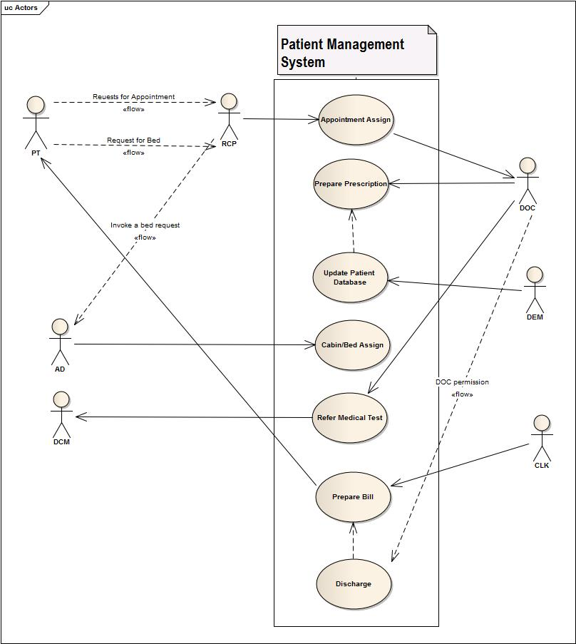

Fig: use-case diagram of patient management system

2.1 Appointment Assign:

|  |  |
| --- | --- |
| USE CASE NAME | DEFINE ROUTE AND PRICE |
| USE CASE ID | 2.1 |
| Priority | Medium |
| Primary Business Actor | RCP |
| External Receiver Actor | Patient |
| Description | RCP assigns PT appointments |
| Trigger | RCP |

**Table:** *Use-Case Narrative:* Appointment Assign

Typical Course of Events:

|  |  |
| --- | --- |
| Actor Action | System Response |
| Step 1. PT wants to visit a DOC | Step 3. System tells whether he is available or not |
| Step 2. RCP searches for availability | Step 5. System Updates DOC appointment list |
| Step 4. RCP appoints an appointment |  |

**Documentation of the use-case 2.1**

**Course of the events**

**Conclusion:**

Concludes when a registered patient is assigned or referred to a doctor.

**Post-condition:**

Doctor gives the patient treatment.

**Implementation Issues:**

A doctor of certain department is assigned to his profile or doctor’s id will be given to his/her profile by the receptionist.

2.2 Prepare Prescription:

|  |  |
| --- | --- |
| USE CASE NAME | DEFINE ROUTE AND PRICE |
| USE CASE ID | 2.2 |
| Priority | High |
| Primary Business Actor | DOC |
| External Receiver Actor | Patient |
| Description | DOC prepares and gives prescription |
| Trigger | DOC |

**Table:** *Use-Case Narrative:* Prepare Prescription

Typical Course of Events:

|  |  |
| --- | --- |
| Actor Action | System Response |
| Step 1. PT visit DOC |  |
| Step 2. DOC prescribes PT |  |

**Documentation of the use-case 2.2**

**Course of the events**

**Conclusion:**

When doctor gives a prescription and uploaded to patient database by generating electrically.

**Post-condition:**

Provides the prescription to the patient representative.

**Implementation Issues:**

A analog hand written prescription will be digitalized and upload to patient database.

2.3 Update Patient Database:

|  |  |
| --- | --- |
| USE CASE NAME | DEFINE ROUTE AND PRICE |
| USE CASE ID | 2.3 |
| Priority | High |
| Primary Business Actor | DEM |
| External Receiver Actor |  |
| Description | DEM updates patients DB with new prescription |
| Trigger | DEM |

**Table:** *Use-Case Narrative:* Update Patient Database

Typical Course of Events:

|  |  |
| --- | --- |
| Actor Action | System Response |
| Step 1. PT take the prescription to DEM | Step 3. System Updates PT account |
| Step 2. DEM insert them to PT account |  |

**Documentation of the use-case 2.3**

**Course of the events**

**Conclusion:**

When all the current information are properly updated to database.

**Post-condition:**

Then database will be there for further changes.

**Implementation Issues:**

The data entry manager will update the system database with update button and patients profile information will get current status.

2.4 Cabin/ Bed Assign

|  |  |
| --- | --- |
| USE CASE NAME | DEFINE ROUTE AND PRICE |
| USE CASE ID | 2.4 |
| Priority | High |
| Primary Business Actor | PT |
| External Receiver Actor | RCP, AD |
| Description | RCP assigns bed/cabin to patient if AD approves it |
| Trigger | RCP |

**Table:** *Use-Case Narrative:* Cabin/ Bed Assign

Typical Course of Events:

|  |  |
| --- | --- |
| Actor Action | System Response |
| Step 1. PT asks RCP for a bed | Step 3. System shows available bed |
| Step 2. RCP searches for available bed | Step 5. System updates bed list and PT account |
| Step 4. RCP assigns a bed to PT |  |

**Documentation of the use-case 2.4**

**Course of the events**

**Conclusion:**

When receptionist assigns a bed or cabin if the patient is required to be admitted or want to be admitted.

**Post-condition:**

Patients will be issued a bed or cabin (if available) and costs starts adding up.

**Implementation Issues:**

Bed or cabin no will be assigned to his/her profile.

2.5 Refer medical test

|  |  |
| --- | --- |
| USE CASE NAME | DEFINE ROUTE AND PRICE |
| USE CASE ID | 2.5 |
| Priority | Medium |
| Primary Business Actor | DOC |
| External Receiver Actor | DCM |
| Description | DOC assigns PT medical tests and DCM receives the requests and organizes the tests |
| Trigger | DOC |

**Table:** *Use-Case Narrative:* Refer medical test

Typical Course of Events:

|  |  |
| --- | --- |
| Actor Action | System Response |
| Step 1. DOC requests medical Test in the system | Step 2. System sends the request to DCM |
| Step 3. DCM receives the request |  |

**Documentation of the use-case 2.5**

**Course of the events**

**Conclusion:**

When doctor prescribes the patient some test if the patients agree to test.

**Post-condition:**

Diagnostic center is informed by system message.

**Implementation Issues:**

The medical tests are listed on the prescription and then send electrically by system to diagnostic center.

2.6: Prepare Bill:

|  |  |
| --- | --- |
| USE CASE NAME | DEFINE ROUTE AND PRICE |
| USE CASE ID | 2.6 |
| Priority | High |
| Primary Business Actor | PT |
| External Receiver Actor | CLK |
| Description | PT pays bill and CLK receives it |
| Trigger | PT |

**Table:** *Use-Case Narrative:* Prepare Bill

Typical Course of Events:

|  |  |
| --- | --- |
| Actor Action | System Response |
| Step 1. CLK prepare bill and add it PT account | Step 2. System updates PT account |
|  |  |

**Documentation of the use-case 2.6**

**Course of the events**

**Conclusion:**

Concludes when all type of charges and costs are added and bill list prepared.

**Post-condition:**

The prepared bill list will be electrically produced and handed to pay.

**Implementation Issues:**

All costs and costs from diagnostic centers are added by calculation of system and bill list can be printed.

2.7 Discharge:

|  |  |
| --- | --- |
| USE CASE NAME | DEFINE ROUTE AND PRICE |
| USE CASE ID | 2.7 |
| Priority | High |
| Primary Business Actor | DOC, CLK |
| External Receiver Actor | PT |
| Description | DOC and CLK provides certificate that he is allowed to leave the hospital and PT is discharged |
| Trigger | DOC |

**Table:** *Use-Case Narrative:* Discharge

Typical Course of Events:

|  |  |
| --- | --- |
| Actor Action | System Response |
| Step 1. DOC approves discharge of a patient | Step 3. System Discharges the PT |
| Step 2. CLK checks for dues in PT account |  |

**Documentation of the use-case 2.7**

**Course of the events**

**Conclusion:**

When patients profile is closed.

**Post-condition:**

The system will preserve patient profile as past patient.

**Implementation Issues:**

Administrator closes the patient profile and doesn’t update it until the patient recontact with hospital.

3. Employee Management System:

Use-case glossary:

|  |  |  |
| --- | --- | --- |
| Use-case ID>Name | Description | Participant Actors and roles |
| 3.1> Employee Profile Creation | AD creates new employee profile for each employee in the hospital | AD,EMP |
| 3.2>Receive and Distribute Duty Schedule | HRO gets the duty schedule from 6.2 and gives it to the EMP | HRO |
| 3.3>View Employee List | AD can view the employee list | AD |
| 3.4>Update Employee Profile | AD can update employee profile, AD can also fire an employee, AD changes the pay scale salary | AD,EMP |
| 3.5> Leave Management | EMP applies for leave , AD grants/denies the request and send it back to Scheduling Subsystem | AD,EMP |

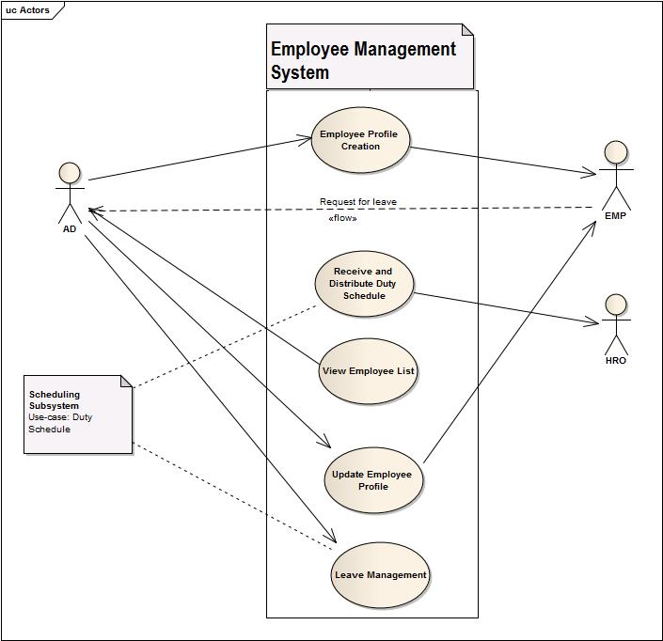

Fig: use-case diagram of Employee Management System

3.1: Employee Profile Creation:

|  |  |
| --- | --- |
| USE CASE NAME | DEFINE ROUTE AND PRICE |
| USE CASE ID | 3.1 |
| Priority | High |
| Primary Business Actor | EMP |
| External Receiver Actor | AD |
| Description | AD registers an EMP in the system |
| Trigger | AD |

**Table:** *Use-Case Narrative:* Employee Profile Creation

Typical Course of Events:

|  |  |
| --- | --- |
| Actor Action | System Response |
| Step 1. Employee Joins the Hospital | Step 4. System Creates EMP profile |
| Step 2. Provides Information to AD |  |
| Step 3. AD insert information in System |  |

**Documentation of the use-case 3.1**

**Course of the events**

**Conclusion:**

Concludes when a employee is adopted and all the informations are gathered in the database.

**Post-condition:**

The employee profile is created and prepared for further use.

**Implementation Issues:**

A System GUI will be provided to entry a employee informations which can be accessed by administrator.

3.2 Receive and Distribute Duty Schedule:

|  |  |
| --- | --- |
| USE CASE NAME | DEFINE ROUTE AND PRICE |
| USE CASE ID | 3.2 |
| Priority | MED |
| Primary Business Actor | HRO |
| External Receiver Actor | EMP |
| Description | HRO receives the duty schedule from the scheduling subsystem  And distributes it among the EMP |
| Trigger | HRO |

**Table:** *Use-Case Narrative:* Receive and Distribute Duty Schedule

Typical Course of Events:

|  |  |
| --- | --- |
| Actor Action | System Response |
| Step 1. HRO receives duty schedule from Scheduling subsystem |  |
| Step 2. HRO distributes them among employees |  |

**Documentation of the use-case 3.2**

**Course of the events**

**Conclusion:**

Concludes when schedules are distributed to the employees.

**Post-condition:**

The employees are notified by some ways(sms or electrical screen).

**Implementation Issues:**

A routine type schedule will be created daily basis for doctors and employees by system and will be displayed on digital screen or notified by sms.

3.3 View Employee List:

|  |  |
| --- | --- |
| USE CASE NAME | DEFINE ROUTE AND PRICE |
| USE CASE ID | 3.3 |
| Priority | Low |
| Primary Business Actor | AD |
| External Receiver Actor |  |
| Description | AD can view the current EMP list |
| Trigger | AD |

**Table:** *Use-Case Narrative:* View Employee List

Typical Course of Events:

|  |  |
| --- | --- |
| Actor Action | System Response |
| Step 1. AD wants to view the admitted PT list | Step 2 . System shows it |

**Documentation of the use-case 3.3**

**Course of the events**

**Conclusion:**

When employee lists is shown on software GUI(with filter searching).

**Post-condition:**

Administrator can do permitted operations on employee (salary increment ,fire etc).

**Implementation Issues:**

All employee lists will be prepared and showed on the GUI based on(with or without filtering) searching and will be provided options for permitted changes.

3.4 Update Employee Profile:

|  |  |
| --- | --- |
| USE CASE NAME | DEFINE ROUTE AND PRICE |
| USE CASE ID | 3.4 |
| Priority | MED |
| Primary Business Actor | EMP |
| External Receiver Actor | AD |
| Description | AD can update information of EMP |
| Trigger | EMP |

**Table:** *Use-Case Narrative:* Update Emp Profile

Typical Course of Events:

|  |  |
| --- | --- |
| Actor Action | System Response |
| Step 1. AD inserts updated information | Step 2. System Updates it |

**Documentation of the use-case 3.4**

**Course of the events**

**Conclusion:**

Concludes when changes made by administrator is updated.

**Post-condition:**

The new information about the employees will now exist in the system and concerned employee will be notified.

**Implementation Issues:**

Administrator views and changes employee information and updates the employee information and employee will be notified by sms.

3.5 Leave Management:

|  |  |
| --- | --- |
| USE CASE NAME | DEFINE ROUTE AND PRICE |
| USE CASE ID | 3.5 |
| Priority | High |
| Primary Business Actor | EMP |
| External Receiver Actor | AD |
| Description | AD has to approve leave for an EMP and Updates DB as so |
| Trigger | EMP |

**Table:** *Use-Case Narrative:* Leave Management

Typical Course of Events:

|  |  |
| --- | --- |
| Actor Action | System Response |
| Step 1. EMP requests for Leave | Step 3. If accepted then Profile is updated |
| Step 2. AD chooses to accept or deny | Step 4. Updated info is sent to Scheduling subsystem |

**Documentation of the use-case 3.5**

**Course of the events**

**Conclusion:**

When employee absence is adapted in the system.

**Post-condition:**

System scheduling and other things will be updated.

**Implementation Issues:**

If administrator accepts the leave prayer then he/she will be notified by sms and system schudling will be done adapted.

3.6 Prepare EMP list:

|  |  |
| --- | --- |
| USE CASE NAME | DEFINE ROUTE AND PRICE |
| USE CASE ID | 3.3 |
| Priority | MED |
| Primary Business Actor | AD |
| External Receiver Actor |  |
| Description | AD prepares the EMP list |
| Trigger | AD |

**Table:** *Use-Case Narrative:* Prepare EMP list

Typical Course of Events:

|  |  |
| --- | --- |
| Actor Action | System Response |
| Step 1. AD asks the system to prepare a list of current EMP | Step 2. System produces the list of EMP who are currently working in the hospital |

**Documentation of the use-case 1.2**

**Course of the events**

**Conclusion:**

Concludes when information about employees is currently stored and ready to be searched.

**Post-condition:**

The administrator is notified about the current employees.

**Implementation Issues:**

List of employee information is stored in database and prepared for filter searching.

4. Diagnostic Center Management

Use-Case Glossary:

|  |  |  |
| --- | --- | --- |
| Use-case ID>Name | Description | Participant Actors and roles |
| 4.1>Receive request | RCP receives a diagnostic test request from PT. | * RCP * PT |
| 4.2>Collect sample | DCA collects diagnostic sample from PT. | * DCA * PT |
| 4.3>Prepare Report | DOC prepares report according to the sample and handles it to the RCP. | * DOC * RCP |
| 4.4>Prepare Bill | CLK prepares bill for the patient | * CLK |
| 4.5>Delivery Report | RCP delivers the report to the PT. | * PT * RCP |

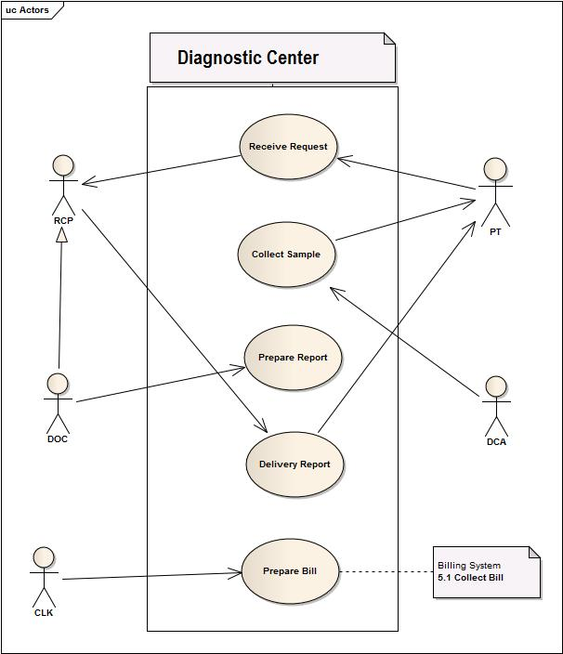

Fig: use-case diagram of Diagnostic Center Management

4.1 Receive Request:

|  |  |
| --- | --- |
| USE CASE NAME | DEFINE ROUTE AND PRICE |
| USE CASE ID | 4.1 |
| Priority | High |
| Primary Business Actor | DOC , PT, |
| External Receiver Actor | DCM, RCP |
| Description | DOC/PT requests medical test and DCM/RCP accepts those |
| Trigger | DOC/PT |

**Table:** *Use-Case Narrative:* Receive Request

Typical Course of Events:

|  |  |
| --- | --- |
| Actor Action | System Response |
| Step 1. DOC / PT request for test |  |
| Step 2. DCM / RCP accepts those |  |

**Documentation of the use-case 4.1**

**Course of the events**

**Conclusion:**

Concludes when medical list for requested patients is arrived and granted.

**Post-condition:**

Preparation for sample collection is taken for the patients.

**Implementation Issues:**

A list of test a patient is sent from doctor prescription and received by diagnostic center mananger.

4.2 Collect Sample:

|  |  |
| --- | --- |
| USE CASE NAME | DEFINE ROUTE AND PRICE |
| USE CASE ID | 4.2 |
| Priority | High |
| Primary Business Actor | PT |
| External Receiver Actor | DCA |
| Description | DCA collects sample from PT |
| Trigger | DCA |

**Table:** *Use-Case Narrative:* Collect Sample

Typical Course of Events:

|  |  |
| --- | --- |
| Actor Action | System Response |
| Step 1. DCA takes sample of the patient |  |

**Documentation of the use-case 4.2**

**Course of the events**

**Conclusion:**

Concludes when sample is collected manually.

**Post-condition:**

The sample is ready to be tested and prepare report.

**Implementation Issues:**

4.3 Prepare Report :

|  |  |
| --- | --- |
| USE CASE NAME | DEFINE ROUTE AND PRICE |
| USE CASE ID | 4.3 |
| Priority | High |
| Primary Business Actor | DOC , DCA |
| External Receiver Actor |  |
| Description | DOC/ DCA prepares report |
| Trigger | DOC/DCA |
|  |  |

**Table:** *Use-Case Narrative:* Prepare Report

Typical Course of Events:

|  |  |
| --- | --- |
| Actor Action | System Response |
| Step 1. DOC / DCA prepares report |  |

**Documentation of the use-case 4.3**

**Course of the events**

**Conclusion:**

Finishes when reports are prepared for patient delivery and uploaded to patient profile database.

**Post-condition:**

Patients are notified that reports are ready.

**Implementation Issues:**

Digital copy of reports will be sent to patient profile.

4.4 Prepare Bill:

|  |  |
| --- | --- |
| USE CASE NAME | DEFINE ROUTE AND PRICE |
| USE CASE ID | 4.4 |
| Priority | High |
| Primary Business Actor | RCP |
| External Receiver Actor | PT |
| Description | RCP prepares the bill and gives to PT |
| Trigger | RCP |
|  |  |

**Table:** *Use-Case Narrative:* Prepare Bill

Typical Course of Events:

|  |  |
| --- | --- |
| Actor Action | System Response |
| Step 1. RCP prepares bill | Step 3. System updates PT account |
| Step 2. bill is added to PT account |  |

**Documentation of the use-case 4.4**

**Course of the events**

**Conclusion:**

When all cost for medical tests are prepared.

**Post-condition:**

Tests are sent to be added to the total costs for concerned patient profile.

**Implementation Issues:**

Diagnostic center assistant entries the costs and system will calculate the others.

4.5 Delivery Report

|  |  |
| --- | --- |
| USE CASE NAME | DEFINE ROUTE AND PRICE |
| USE CASE ID | 4.5 |
| Priority | High |
| Primary Business Actor | RCP |
| External Receiver Actor | PT |
| Description | RCP delivers report to PT |
| Trigger | PT |

**Table:** *Use-Case Narrative:* Delivery Report

Typical Course of Events:

|  |  |
| --- | --- |
| Actor Action | System Response |
| Step 1. RCP checks for dues status | Step2. System provides dues status |
| Step 3. RCP delivers the report to PT | Step 4. PT also emails the report |

**Documentation of the use-case 4.5**

**Course of the events**

**Conclusion:**

When patients are handed the reports to their email address or hard copy.

**Post-condition:**

Doctors can view the reports.

**Implementation Issues:**

Prepared digital copy of the reports will be sent to their email or the hard copy will be given.

5. Billing System:

Use-case Glossary:

|  |  |  |
| --- | --- | --- |
| Use-case ID>Name | Description | Participant Actors and roles |
| 5.1>Collect Bill Information | CLK collects all billing information from different sub system | CLK |
| 5.2>Receive bill | PT gives total bill to CLK | PT,CLK |
| 5.3> Produce Receipt | CLK produces receipt for patient | CLK |

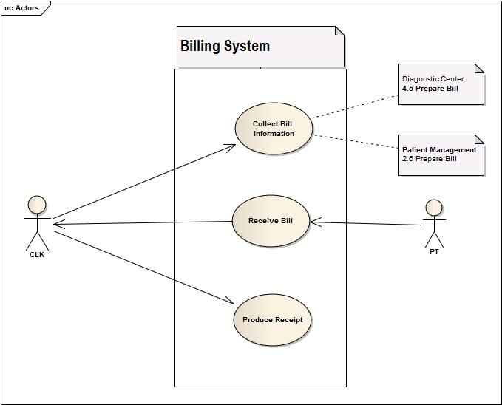

Fig: use-case diagram of Billing System

5.1Collect Bills from other subsystems:

|  |  |
| --- | --- |
| USE CASE NAME | DEFINE ROUTE AND PRICE |
| USE CASE ID | 5.1 |
| Priority | High |
| Primary Business Actor | CLK |
| External Receiver Actor |  |
| Description | CLK collects all bills from Patient profile |
| Trigger | CLK |

**Table:** *Use-Case Narrative:* Collect Bills from other subsystems

Typical Course of Events:

|  |  |
| --- | --- |
| Actor Action | System Response |
| Step 1. CLK checks for all bills in PT account | Step 2.System shows the pt account |
|  | Step 2. System collects all bills and prepare them |

**Documentation of the use-case 5.1**

**Course of the events**

**Conclusion:**

Concludes when all costs and costs sent from other systems are summed up.

**Post-condition:**

System will prepare full bill list.

**Implementation Issues:**

All services charges,doctor fees,cabin or bed cost(depends on how long patients stayed),diagnostic costs are added.

5.2 Receive Bill:

|  |  |
| --- | --- |
| USE CASE NAME | DEFINE ROUTE AND PRICE |
| USE CASE ID | 5.2 |
| Priority | High |
| Primary Business Actor | PT |
| External Receiver Actor | CLK |
| Description | PT pays bill to CLK |
| Trigger | PT |

**Table:** *Use-Case Narrative:* Receive Bill

Typical Course of Events:

|  |  |
| --- | --- |
| Actor Action | System Response |
| Step1. PT pay bill to CLK | Step 2. System updates PT account |

**Documentation of the use-case 5.2**

**Course of the events**

**Conclusion:**

When patient profile will be updated as all costs paid.

**Post-condition:**

System will provide the patient discharge grant through administrator.

**Implementation Issues:**

Costs paid by the patients will be sent to patient profile to be cleared up and remove dues status.

5.3 Produce Receipt:

|  |  |
| --- | --- |
| USE CASE NAME | DEFINE ROUTE AND PRICE |
| USE CASE ID | 5.3 |
| Priority | High |
| Primary Business Actor | CLK |
| External Receiver Actor | PT |
| Description | CLK produces receipt and gives it to PT |
| Trigger | CLK |

**Table:** *Use-Case Narrative:* Produce Receipt

Typical Course of Events:

|  |  |
| --- | --- |
| Actor Action | System Response |
| Step 1. CLK asks system for receipt | Step 2. System prints a receipt |

**Documentation of the use-case 5.3**

**Course of the events**

**Conclusion:**

All costs or bill lists are printed by the system

**Post-condition:**

Patients received money receipt with all costs paid or unpaid if patients want to see bill list.

**Implementation Issues:**

All types of costs from different sources are listed in a form and thus generate electrically printed receipt.

6. Scheduling System

Use-case Glossary:

|  |  |  |
| --- | --- | --- |
| Use-case ID>Name | Description | Participant Actors and roles |
| 6.1>Active Employee List | AD gets the active employee list | AD |
| 6.2>Duty Schedule | AD specifies duty schedules of all employees | AD |

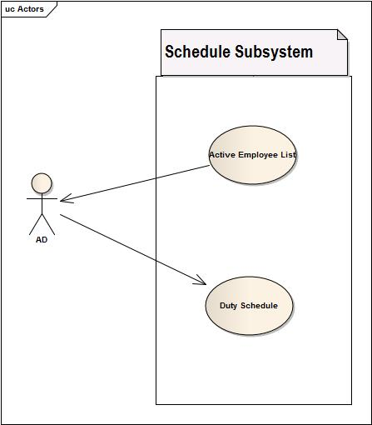

Fig: use-case diagram of Scheduling System

6.1 Receive Active Employee

|  |  |
| --- | --- |
| USE CASE NAME | DEFINE ROUTE AND PRICE |
| USE CASE ID | 6.1 |
| Priority | Med |
| Primary Business Actor | AD |
| External Receiver Actor |  |
| Description | System receive active employee list |
| Trigger | AD |

**Table:** *Use-Case Narrative:* Receive Active Employee

Typical Course of Events:

|  |  |
| --- | --- |
| Actor Action | System Response |
|  | Step 1.Receive the list of active employees |

**Documentation of the use-case 6.1**

**Course of the events**

**Conclusion:**

Concludes by preparing a list of employee who are currently active.

**Post-condition:**

All active employees will be ready to be scheduled.

**Implementation Issues:**

A list will be prepared by system depending on on-leave status of the employee and other criterias.

6.2 Duty Schedule

|  |  |
| --- | --- |
| USE CASE NAME | DEFINE ROUTE AND PRICE |
| USE CASE ID | 6.2 |
| Priority | High |
| Primary Business Actor | AD |
| External Receiver Actor |  |
| Description | System produces duty schedule |
| Trigger | AD |

**Table:** *Use-Case Narrative:* Duty Schedule

Typical Course of Events:

|  |  |
| --- | --- |
| Actor Action | System Response |
|  | Step 1. Produce a work schedule for all emp |
|  | Step 2. Send it to HRO |

**Documentation of the use-case 6.2**

**Course of the events**

**Conclusion:**

Concludes when all duty schedule are prepared checking employees information.

**Post-condition:**

Concerned employee will be notified for their duties.

**Implementation Issues:**

A digital screen will show schedule list. Also employee will be notified by sms according to their tasks.